***RIPHAH INTERNATIONAL UNIVERSITY GCC CAMPUS***

|  |  |  |  |  |
| --- | --- | --- | --- | --- |
| **NAME** | **SAP** | **DEP** | **COURSE** | **LAB** |
| **TEHREEM IJAZ** | **62688** | **FC** | **BSCS** | **10** |

# Task 1:

# Write a program in C++ to swap two numbers using function.

#include <iostream>

using namespace std;

// Pass by Value

void swapByValue(int a, int b) {

int temp = a;

a = b;

b = temp;

cout << "After Swap (By Value): a = " << a << ", b = " << b << endl;

}

// Pass by Reference

void swapByReference(int &a, int &b) {

int temp = a;

a = b;

b = temp;

cout << "After Swap (By Reference): a = " << a << ", b = " << b << endl;

}

int main() {

int x, y;

cout << "Enter two numbers: ";

cin >> x >> y;

cout << "Before Swap: x = " << x << ", y = " << y << endl;

// Call functions

swapByValue(x, y);

cout << "After Swap (Original Values): x = " << x << ", y = " << y << endl; // No change in original values

swapByReference(x, y);

cout << "After Swap (Updated Values): x = " << x << ", y = " << y << endl; // Original values changed

return 0;

}

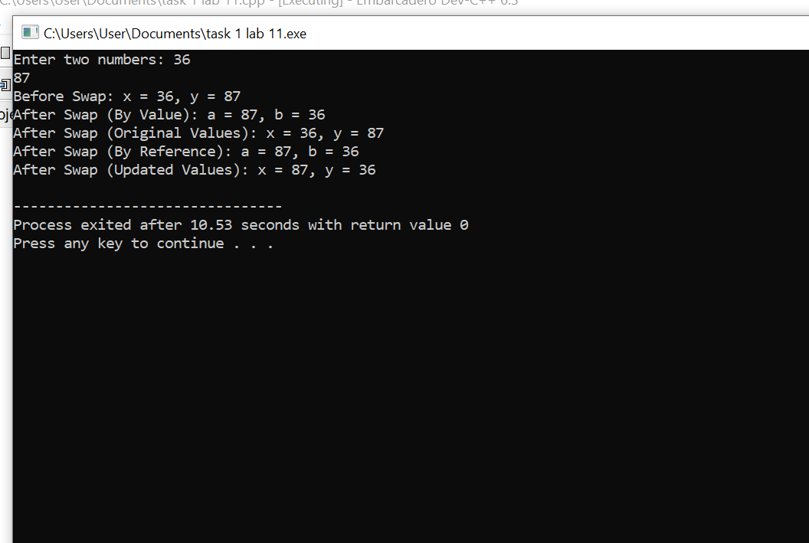

# Task 2:

# Write a function which inputs three integers compare these integers, return the largest of three integer

# and display the largest integers.

#include <iostream>

using namespace std;

int findLargest(int a, int b, int c) {

int largest = (a > b) ? (a > c ? a : c) : (b > c ? b : c);

return largest;

}

int main() {

int num1, num2, num3;

cout << "Enter three integers: ";

cin >> num1 >> num2 >> num3;

int largest = findLargest(num1, num2, num3);

cout << "The largest number is: " << largest << endl;

return 0;

}

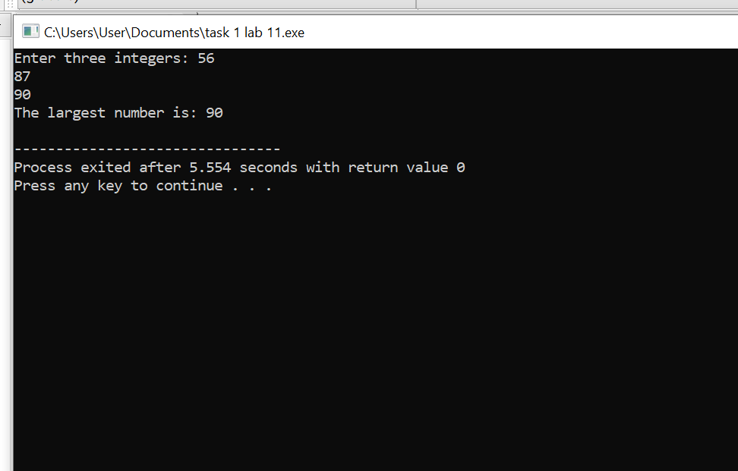

# Task 3:

Write a code that take numbers from user and displays its cube. The Code should reads integers and prints their cubes until the user inputs the sentinel value 0. Each integer read should be passed to the cube() function by the call cube(n). The value returned by the function should replaces the expression cube(n) and then should be passed to the output object cout.

#include <iostream>

using namespace std;

int cube(int n) {

return n * n * n;

}

int main() {

int num;

cout << "Enter numbers to find their cube (enter 0 to stop):" << endl;

while (true) {

cin >> num;

if (num == 0) break;

cout << "Cube of " << num << " is: " << cube(num) << endl;

}

return 0;

}

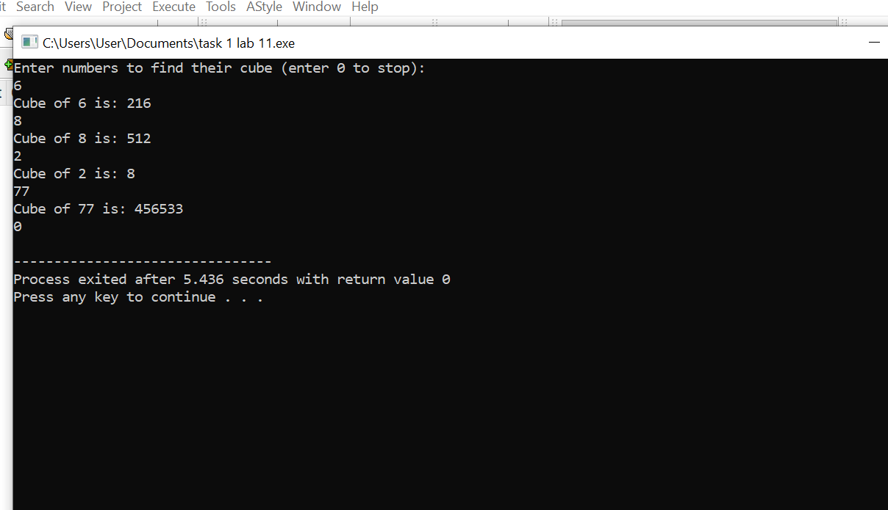

**Task 4**

Develop a program in C++ that has function printTempOpinion() which prints "Cold" on if the temperature is below 10, "OK" if the temperature is in the range 20 -> 30,"Hot" if the temperature

#include <iostream>

using namespace std;

void printTempOpinion(int temp) {

if (temp < 10)

cout << "Cold" << endl;

else if (temp >= 20 && temp <= 30)

cout << "OK" << endl;

else if (temp > 30)

cout << "Hot" << endl;

else

cout << "Temperature does not fit any category!" << endl;

}

int main() {

int temp;

cout << "Enter the temperature: ";

cin >> temp;

printTempOpinion(temp);

return 0;

}

